03.05
LONG TERM PLANNING
Process Design & AMOS Configuration Document
Purpose
This Process Design document is provided to Key-Users to record their key decisions regarding the AMOS Process design and the required AMOS configuration.
It is updated throughout the Project Definition Phase and used as the baseline for the Final Acceptance prior to Go-Live
Revision
Author, Name | Date | Notes
Adriano Azzurretti | 01.06.2024 | First Version
Jakub Sadowski | 01.06.2025 | Revision 1 – Visio diagram update

Table of Contents

1. Process Overview & Objectives 3
2. Regulatory References 3
3. Definitions & Glossary 3
4. Process Tasks 4
5. Process Dependencies 4
6. Process Flow 5
7. Process Design Questions 7
8. Data (Source) Mapping 8
9. Other Software Used 8
10. AMOS Configuration 9
a. Basic Data 9
b. Parameters 9
c. Workflows 9
d. Scheduled Tasks 9
e. API’s & Interfaces 10
11. UAT Guidance 10
12. Annex – Additional Info 10

Process Overview & Objectives

Process General Description:
The process covers the management and control of the continuous airworthiness of the fleet on a long-term timeframe, through the planning of maintenance layovers in which to perform the maintenance tasks due.
Main drivers for the generation of maintenance layovers are the aircraft availability for maintenance (available slots), the maintenance requirements due dates and their interval's utilisation.
Given the many variables to consider in the long-term planning process (e.g., fleet plans, flight operations plans, financial constraints, commercial campaigns, contracted MROs, etc.) it is common to assess many different maintenance plans at the same time, each matching a different scenario. Among them, only the chosen one is published and used productively as the operational plan.
Main Process Objective (Outputs & Outcomes):
Output of this process is an updated maintenance layover plan matching all the operational, technical and airworthiness constraints, and spanning over a long-term timeframe – typically, from one to five years.
On top of the impacts in terms of strategic planning, this output is particularly important in the financial costs control of an airline. In fact, it is a necessary input in the calculation of the budget to be allocated for the maintenance of the fleet.
Please note that the scope of the long-term planning process is usually limited to the detailed planning of the base maintenance letter checks, major components replacement and major modifications. Whilst the volumes of the maintenance activities below the C-check interval are considered in the maintenance budgeting process, the relevant detailed layover plan is only considered on a shorter term.

Regulatory References

- EASA Part M - Subpart B M.A.201 Responsibilities
- EASA Part M - Subpart C M.A.301 Continuing airworthiness tasks
- EASA Part M - Subpart C M.A.303 Airworthiness Directives
- EASA Part CAMO - CAMO.A.315(b)(5) Continuing airworthiness management
- FAA Title 14 CFR § 121.363 Responsibility for Airworthiness
- FAA Title 14 CFR § 91.405 Maintenance Required
- FAA Title 14 CFR § 91.409 Inspections

Definitions & Glossary

Keywords | Explanation
Work Package | An object representing a Maintenance Layover in AMOS, which can contain the maintenance events to be performed during the layover itself
Leading Event in a Work Package | The check, the engineering document or the task that requires the longer ground time and/or the more resources in a work package. In the maintenance plans generation and update, it is the pivotal event of the maintenance layover, around which the work package content is built adding out-of-phase events or minor maintenance checks.
Maintenance Item / Maintenance Event | A scheduled or unscheduled maintenance task to be performed on the aircraft
Check | A collection of tasks that can be planned as a single Maintenance Item
Single Running Task Card | Free routine task that can be planned as a stand-alone item

Process Tasks

Business Process Task / Actions / Activities:
- Review and update of the daily aircraft utilisation (seasonally)
- Creation of a simulated plan / scenario
- Staggering of the maintenance layovers concerned by a scenario based on the desired interval utilisation and the operational constrains – i.e., fleet availability for maintenance operations
- Update of an existing plan /scenario
- Publishing a simulated plan to production

Process Dependencies

Input
- AMOS Business Processes 01.03 – Maintenance Program, 01.02 – Parts Definition, 01.04 – Documents Assessment: Plannable events considered in the long-term planning are generated by these Business Processes – respectively for Task Cards and Checks, Parts Requirements, Engineering Documents. To each of these events is associated a ground time that is considered as the default one in the long-term planning process
Output
- AMOS Business Process 03.01 – Planning: the already planned layovers are included into a scenario at its creation and can be considered in the long-term planning process. On the other way around, when a scenario is published as an output of the long-term planning process, work packages containing the leading planned events are generated and made available to be managed in the frame or the Planning Business Process.

Process Flow
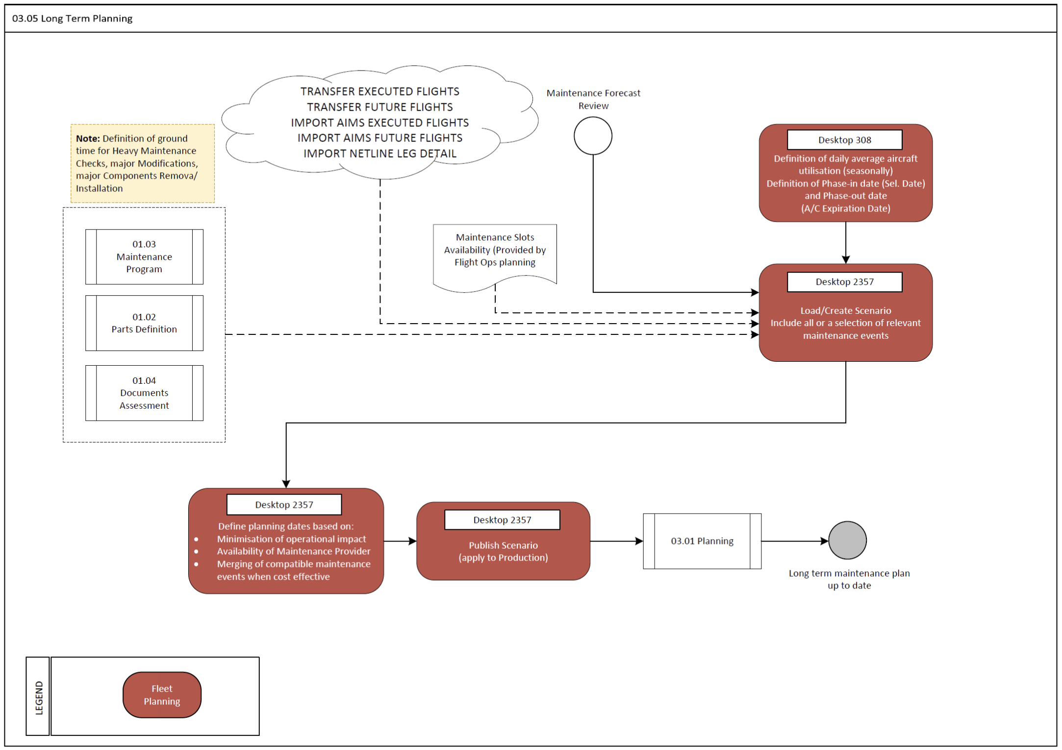

Process Flow Notes:
- The Long-Term Planning process focuses on the big picture: checks and tasks with shorter term intervals, Single Running Task Cards, minor components replacement and similar maintenance events can – and should – be filtered out from a long-term planning scenario.
- Whilst there can be many simulated scenarios covering the same period and scope, only one of them can be published – using the “apply to production” feature in the long-term planning APN – and made visible as the operative plan in every other AMOS APN. The access to this feature shall be restricted as it has a cascade impact on every other planning process.
- The layovers generated within APN 2357 only carries limited information (including a provisional work package number assigned): no correspondent Work Package is created in AMOS until the relevant scenario is not published
- Flights can be imported from the Flight Ops. System using the available APIs to refine the calculation of the aircraft utilisation for the calculation of the next due values.

Process Design Questions

# | Question | Answer
1 | Is there a separate responsible department for the long-term Maintenance Plans in your organization?
2 | Where is this department allocated?
3 | How is this department organized internally? (e.g., wide/narrow bodies, ATA chapter…)
4 | Does the average aircraft utilization change seasonally?
5 | Who oversees the setting of the average aircraft utilization used for the calculation of the next due dates of maintenance events with interval other than calendar days?
6 | How is the fleet availability for maintenance defined?
7 | Do you use contracted maintenance providers for Base Maintenance?
8 | How long in advance are maintenance slot reserved for base maintenance? Is there any relevant difference in the Service Level Agreements for external maintenance providers?
10 | How often do you revise your maintenance plans? Is there any standard interval?
11 | Is the availability of the (internal) MRO resources a driver for the planning of maintenance layovers?

Data (Source) Mapping

Data Sources | Description | Volume / Manual / Automatic / Static / Dynamic

Other Software Used

Other Softwares | Used by: | Description

AMOS Configuration

APN 2357 – Long Term Planning: Please make sure to show the column “Yield” in the Forecast Display to see the interval utilisation.

Basic Data

Basic Data Table | Notes
Time Requirement Defaults | Defines the default Time Requirement Next Due Calculation Strategy for different kind of maintenance events
Priority | All workorders have a priority. Default priorities range between 1 for highest priority to 5 for lowest priority including some special priorities are defined in this table.

Parameters

Parameter Code | Parameter Name | Notes | Comments / Decisions
857 | INITIALIZE FUTURE EVENTS | This parameter informs the system if future events should be initialized | Int = 5,  Float = 1095,  String = Y
1687 | Activate the NullLegsFiller daemon | The activation of the NullLegsFiller daemon impacts the calculation of the next due date (using counters other than calendar days) for those aircrafts with days in the past with no flight activity. Without null leg, the average daily values are applied for those days in the forecast computation. | String = Y

Workflows

Workflow Number | Workflow Name | Notes
NIL

Scheduled Tasks

Scheduled Task Reference | Frequency | Notes
Forecast Sequence, including:  EffectivityApplicabilityService  EffectivityConsistencyTask  RecalculateFutureEventsService  CheckExpiredSoftwaresTask  AircraftMaintenanceForecastService  ComponentMaintenanceForecastService  PartForecastService | Daily

API’s & Interfaces

Reference | Direction | Trigger | Frequency
TRANSFER EXECUTED FLIGHTS | Import | Scheduler Task or Webservice | Every 2-5 mins.
TRANSFER FUTURE FLIGHTS | Import | Scheduler Task or Webservice | Every 2-5 mins.
IMPORT AIMS EXECUTED FLIGHTS | Import | Scheduler Task or Webservice | Every 2-5 mins.
IMPORT AIMS FUTURE FLIGHTS | Import | Scheduler Task or Webservice | Every 2-5 mins.
IMPORT NETLINE LEG DETAIL | Import | Scheduler Task or Webservice | Every 2-5 mins.

UAT Guidance

Annex – Additional Info

